**Lab Assignment No 2 College Database**

Consider following databases and draw ER diagram and convert entities and relationships to relation table for a given scenario. And then write SQL statements for following queries.

**COLLEGE DATABASE**

STUDENT (USN, SName, Address, Phone, Gender)

SEMSEC (SSID, Sem, Sec)

CLASS (USN, SSID)

SUBJECT (Subcode, Title, Sem, Credits)

MARKS (USN, Subcode, SSID, Test1, Test2, Test3, FinalIA)

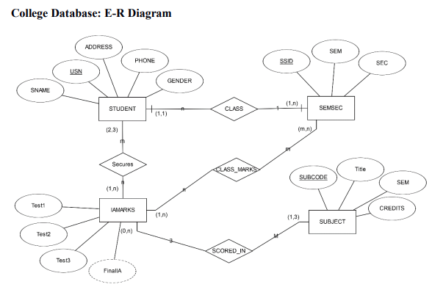

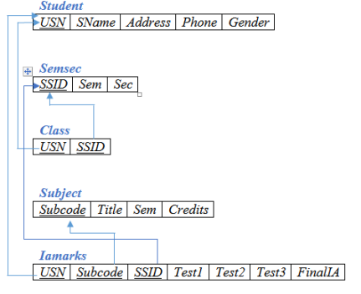

1. Insert any 10 records to each of the tables.
2. Change address of Student ‘Nikin’ to Lalitpur
3. Delete record of ‘Pravin’ student
4. Display address of all students.
5. Display distinct address of all students. a
6. Display records of all male students.
7. Display name and address of all female student.
8. Display title of all subjects whose credit hours less than 4.
9. Display records of all subjects whose credit hours greater than 3.
10. Display records of all subjects whose semester not equal to BCA-4th
11. Display records of all subjects whose semester not equal to BCA-4th and credit hours greater than 3
12. Display records of all subjects whose semester not equal to BCA-4th or credit hours greater than 3
13. Display records of all marks in which student gets marks between 40 to 50 in test1
14. Display records of all marks in which student gets marks not between 40 to 50 in test1
15. Display records of all students of address either Kathmandu or Bhaktapur or Lalitpur by using IN operator.
16. Display records of all students of address except Kathmandu, Bhaktapur and Lalitpur by using NOT IN operator.
17. Display records of all students of name start with ‘P’
18. Display records of all students of name end with ‘n’
19. Display records of all students of name contains sub string ‘m’
20. Display records of all students of name length 4.
21. Display records of all students of name length at least 5.
22. Display all records of marks table by renaming all of the attributes according to your needs.
23. Find maximum and minimum marks in test1.
24. Find total marks in test3.
25. Find total students in each address level of student table.
26. Find total male and female students.
27. Find address and total students in each address level of student table with number of student greater than 1.
28. Find cross join of student and marks table.
29. Find inner join of student and marks table
30. Find left outer join of student and marks table
31. Find right outer join of Marks and student tables
32. Find full outer join of Student and marks table
33. Find name of those student of phone no is maximum.
34. Find name of those student who get maximum marks in test3 examination.

**Creating the database and College and the tables inside the database.**

create database college

create table Student

(Usn int primary key,

Sname varchar(20),

Addr varchar(20),

Phone numeric(10) unique,

Gender varchar(10));

create table SemSec

(Ssid int primary key,

Sem varchar(10),

Sec varchar(5));

create table Class

( Usn int,

foreign key (Usn) References

Student(Usn),

Ssid int,

foreign key(Ssid) References

Semsec(Ssid));

create table Subject

( subcode varchar(10) primary key,

title varchar(10),

sem varchar(10),

credits int);

create table Marks

(Usn int,

foreign key(Usn) References

Student(Usn),

Ssid int,

foreign key(Ssid) References

SemSec(Ssid),

subcode varchar(10),

foreign key (subcode) References

Subject(subcode),

Test1 int,

Test2 int,

Test3 int,

FinalIA varchar(10));

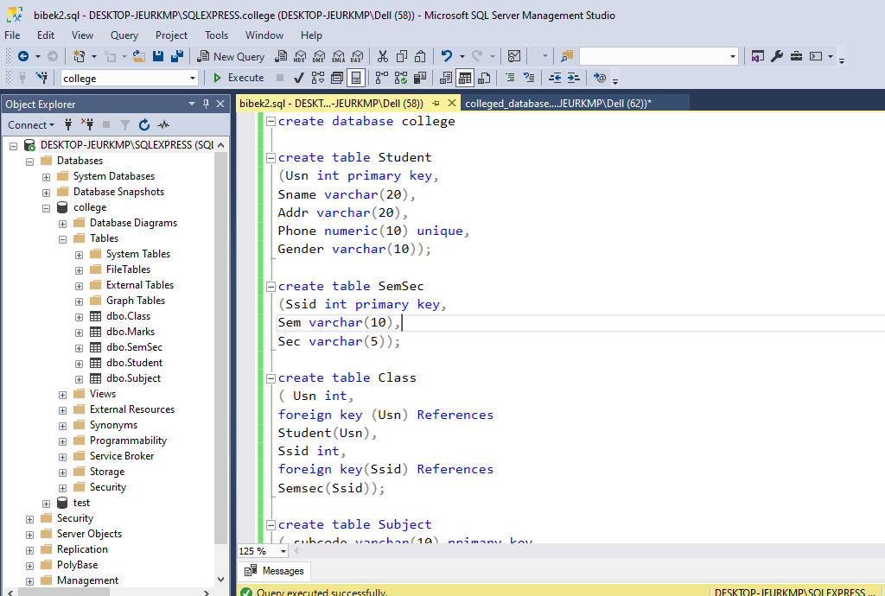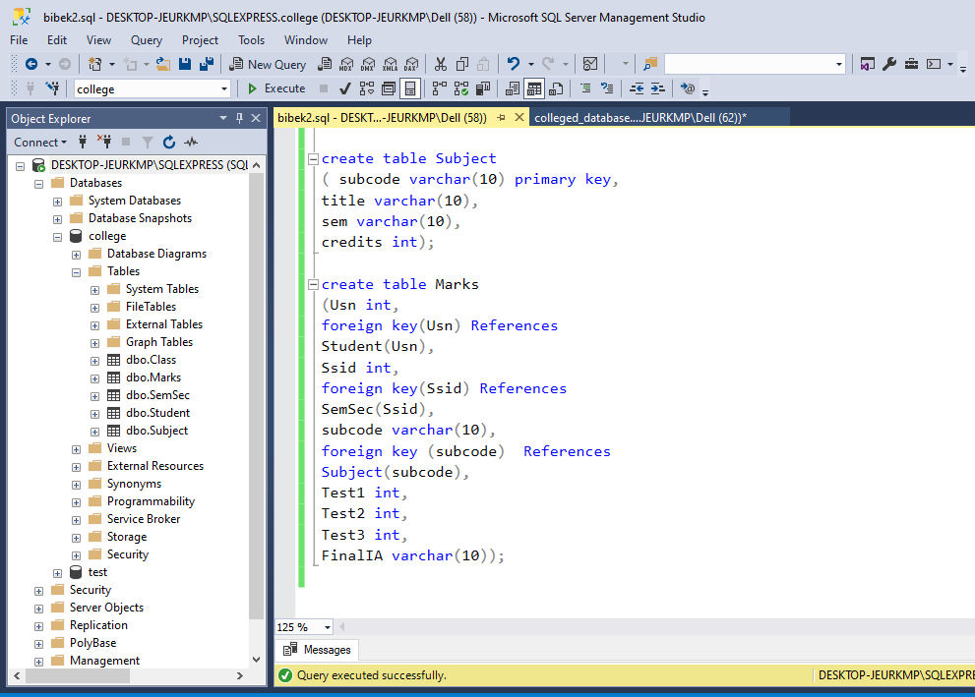

**Student Table:**

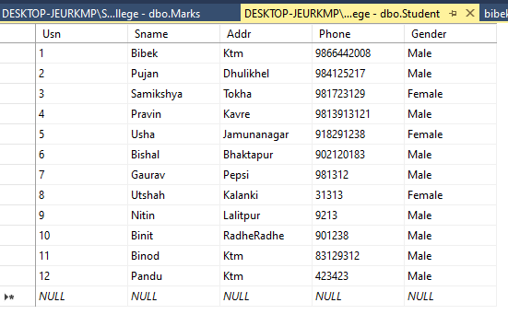

**SemSec table:**

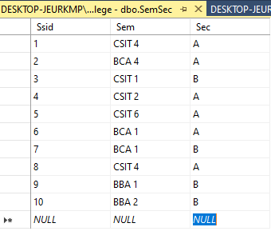

**Class Table:**

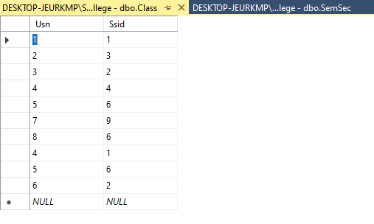

**Subject Table:**

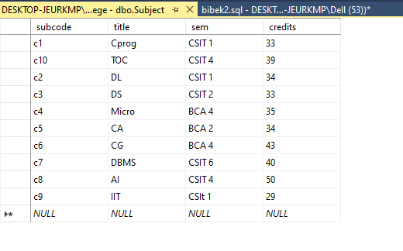

**Marks table:**

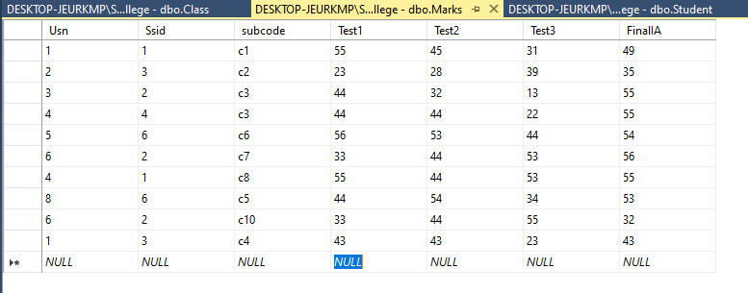

2. Change address of Student ‘Nitin’ to Lalitpur.

update Student

set Addr='Lalitpur'

where Sname='Nitin'

select*from Student

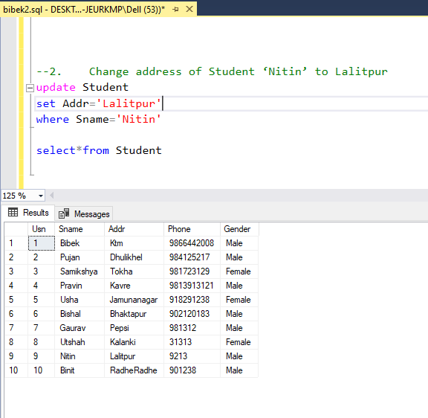

--3. Delete record of ‘Pravin’ student

delete from Class

where Usn=4

delete from Marks

where Usn=4

delete from Student

where Sname='Pravin'

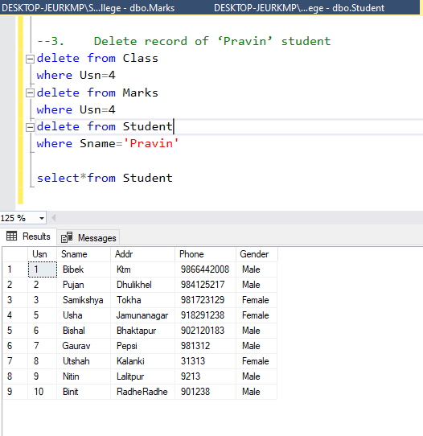

--4. Display address of all students.

